Name: __________________________________ Core:______________ Term 4 Week 6

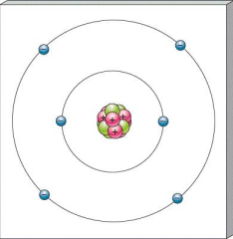
- How many valance electrons does carbon have?

- Draw a Lewis Dot Structure for the element Neon. Neon is in family 8.

- The atomic number of an atom is
  - The mass of the atom
  - The number of protons added to the number of neutrons
  - The number of protons
  - Negatively charged.

- How many atoms are in the following chemical formula? C₆H₆O

- How many elements are in the following chemical formula? C₆H₆O

- How are the elements in periodic table organized?
  - Mass
  - Chemical properties
  - Randomly
  - Both a and b

