Name: __________________________________ Core:______________ Term 6 Week 4
- What is the height of the wave called?

- What is the number of waves in an amount of time?

- What type of wave is shown below?
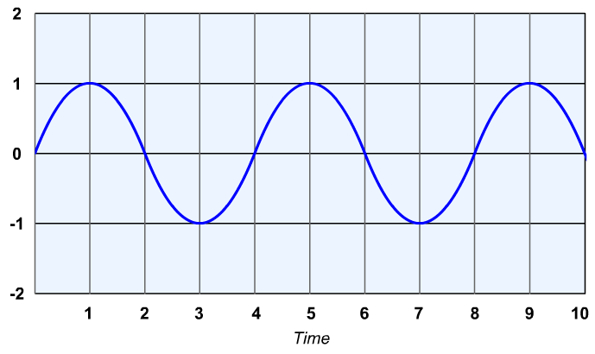
Height of wave in (cm)
a. transverse wave b. longitudinal wave c. combined wave d. sound wave
- What is the amplitude and wavelength of the wave shown below?
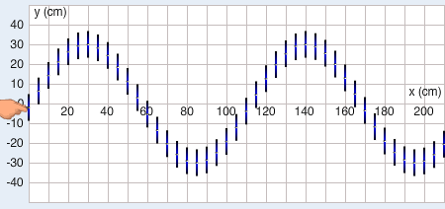
a. amplitude of 30 cm; wavelength 60 cm c. amplitude of 60 cm; wavelength 110 cm
b. amplitude of 60 cm; wavelength 60 cm d. amplitude of 60 cm; wavelength of 110 cm
- What is the amplitude and wavelength of the wave shown below?
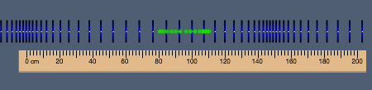
a. amplitude of 15 cm; wavelength 150 cm c. amplitude of 30 cm; wavelength of 150 cm
b. amplitude of 30 cm; wavelength of 200 cm d. amplitude of 150 cm; wavelength 30 cm

