Name: __________________________________ Core:______________ Term 1 Week 3

- The higher the temperature of water, the faster the egg will cook. What is the independent variable?
  - Temperature of water
  - Egg
  - Cook time
  - None of the above
- Grass will grow taller if it is watered and fertilized more. What is the dependent variable?
  - Grass height
  - Water
  - Fertilizer
  - B and C
- Which of the following is NOT a need of a seed?
  - Water
  - Warmth
  - soil
  - Air
- Which of the following is not a characteristic of a living thing?
  - It reproduces
  - It is made up of at least one cell
  - It can adapt
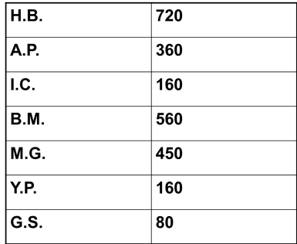
  - It is solid
- What is the data table missing?
  - Title
  - Labels
  - Units
  - All of the above

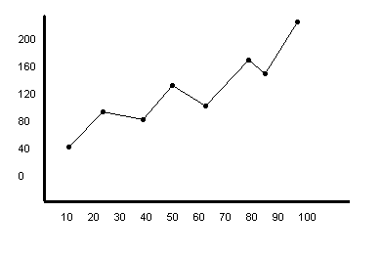
- Fill in on the graph below what is missing.

