Waves Study Guide
From your notes:
Wave anatomy
Waves gizmo
Readings – light and sound
Light definitions
Analog vs. digital
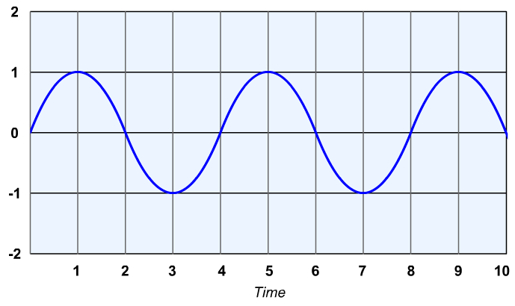
- Label the following on the wave at right
  - Crest
  - Trough
  - Wavelength
  - Amplitude

- What is the frequency of a wave?

- What is the difference between a transverse and longitudinal wave?

- What happens when light hits a shiny or smooth surface?

- What is it called when light bends as it moves from one substance to another?

5. What happens when a beam of light hits an object?
A. Light passes through it. C. All the light is absorbed.
B. A shadow forms. D. All the light is reflected

6. What color is an object that absorbs all of the colors in the light spectrum?
A. rainbow B. white C. black D. invisible

7. A leaf is green. What does this tell you about the light being absorbed?

8. What is the difference between analog and digital signals?

