Unit 2 Common Assessment Study Guide
Review the following worksheets in preparation for your test:
- Seed Dissection
- Roots and Shoots
- Secret Garden
- Microscope Views of Roots – Root Development (on back)
- Leaf and Stem Observations
- Plant Reproduction
- Diversity of Life Book Notes
- Cells R Us
- Animals and Plants Cell Worksheet
- Prokaryotic vs. Eukaryotic Cells

- What are the different parts of a seed and what is their function?
  - ______________________________________________
  - ______________________________________________
  - ______________________________________________
- Which parts of the seed grows first, the root or shoots? Why?
____________________________________________________________________________________________________________________________________________________________________
- What are the different parts of a root and what is their function?
  - ______________________________________________
  - ______________________________________________
  - ______________________________________________
  - ______________________________________________
  - ______________________________________________
  - ______________________________________________
- What is the job of the xylem and where is it located?
____________________________________________________________________________________________________________________________________________________________________
- What is the job of the stomates and where are they located?_________________________________________________________________________________________________________________________________________________________________
- How do plants reproduce? (5 main steps)
______________________________________________________________________________________________________________________________________________________________________________________________________________________________________________________________________________________________________________________________________________________________________________________________________________________________________________________________________________________________________________________________________________________________________________________________
- What are the different parts of a cell and their jobs?
  - ___________________________________________________________________
  - ___________________________________________________________________
  - ___________________________________________________________________
  - ___________________________________________________________________
  - ___________________________________________________________________
  - ___________________________________________________________________
  - ___________________________________________________________________
  - ___________________________________________________________________
  - ___________________________________________________________________
  - ___________________________________________________________________
- What is the difference between a plant and animal cell?
____________________________________________________________________________________________________________________________________________________________________
- What is the difference between prokaryotic cells and eukaryotic cells?
____________________________________________________________________________________________________________________________________________________________________
- When setting up a data table, should the independent variable be listed in the right or left column? Dependent?
____________________________________________________________________________________________________________________________________________________________________
- When setting up a graph, the independent variable should be listed on what axis? Dependent?
____________________________________________________________________________________________________________________________________________________________________
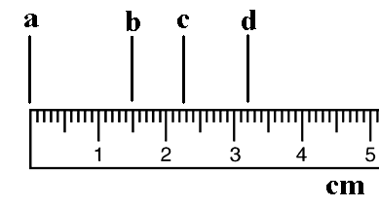
- List each of the following measurements to the nearest tenth.

  - _________

  - _________

  - _________

  - _________

