Name:________________________________ Date:_________ Core:_________

Unit 1 Common Assessment Study Guide

Review the following worksheets in preparation for your test:
- Needs of Seeds
- Five Materials Observations/Conclusion
- Characteristics of Living Things Notes
- Data Tables vs. Graphing Notes
- Microscope Care and Use/Microscope Labs
- Diversity of Life Book Notes

- What does a seed need in order to sprout?

- What are the characteristics of living things?

  - ____________________________

  - ____________________________

  - ____________________________

  - ____________________________

  - ____________________________

  - ____________________________

  - ____________________________

  - ____________________________

- What does each of the following need to grow?
  - Yeast

  - Brine shrimp

  - Radish seeds

- What does dormancy mean?

- How many millimeters is the field of view when using the 4x objective lens?

- How many millimeters is the field of view when using the 10x objective lens?

- How do you find out the total magnification of the microscope?

- What is an independent variable?

- What is a dependent variable?

- A group of middle school students were given a short course in speed reading. The instructor was curious if a monetary incentive would influence performance on a reading test taken at the end of the course. Half of the students were offered $5.00 for obtaining a certain level of performance. The other half were not offered money. Grades for performance were taken at the end of the test. Please identify each of the following:

  - Independent variable –

  - Dependent variable –

  - Control -

- When setting up a data table, should the independent variable be listed in the right or left column? Dependent?

- When setting up a graph, the independent variable should be listed on what axis? Dependent?
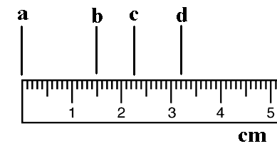
- List each of the following measurements to the nearest tenth.

  - _________

  - _________

  - _________

  - _________

- Barry was curious to see if the amount of light affects the way plant grows. He set up 10 plants that received different amounts of light for ten days. Plants that received 2 hours of light grew an average of 1.0 cm. Plants that received 4 hours of light grew an average of 2.0 cm. Plants that received 6 hours of light grew an average of 3.2 cm. Plants that received 8 hours of light grew an average of 4.4 cm. Plants that received 10 hours of light grew an average of 4.0 cm. Using a separate piece of graph paper, create a data table and graph for Barry so he can easily show his results to others.

