Maria did not make a data table when she performed her experiment but she did take these notes. Organize Maria’s data into a data table. After the data table is complete make one graph of the data for both the soil and the water. Use 2 sheets of graph paper—one for the data table and one for the graph. You have rulers and colored pencils at your table should you need them.

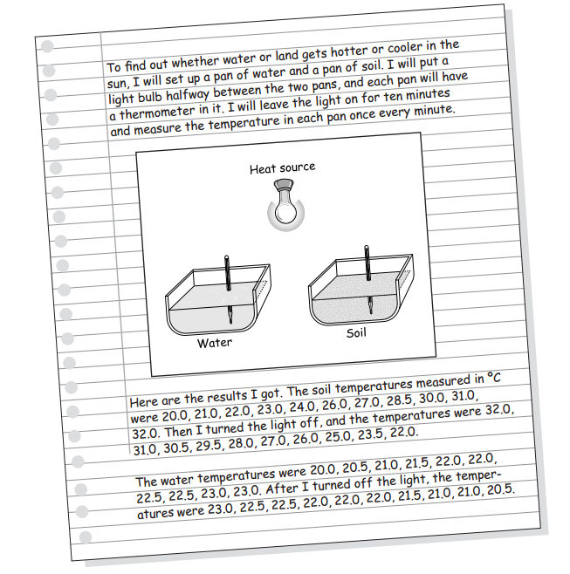

6.EE.C.9 Analyze the relationship between the dependent and independent variables using graphs and tables. (07-LS1-1),(07-LS1-2),(07-LS1-3)

Tables: __________ / 10
Graphs: _________ / 10

