Name:_________________________________ Date:________________ Core:________
Cell Membrane: Diffusion and Osmosis
07-LS1-2 Within cells, special structures are responsible for particular functions, and the cell membrane forms a boundary that controls what enters and leaves the cell.
Diffusion is the movement of particles from areas of higher concentration to areas of lower concentration. This is a natural, random process which means that it does not require extra energy input.
- These are pictures of molecules frozen at two different times. Draw arrow to show the direction each particle might travel due to diffusion in diagrams A and B.

A | B

- Describe the way the molecules move.

- Explain how after a while why the molecules would look like they do in Diagram B.

- Complete the following sentence: Diffusion is the _________________ movement of particles

from ___________ concentration to ___________ concentration.
Osmosis is the diffusion of water across a semi permeable membrane. The semi permeable membrane acts like a filter that lets only the water through. Water always goes from the area of higher water concentration to the area of lower water concentration.
On the following diagram label the:
- Semi-permeable membrane (M)
- Area of higher water concentration (HC)
- Area of lower water concentration (LC)
- Direction of osmotic flow (arrow)

- What happens to the number of water particles on the left hand side?

- What happens to the concentration of the solution on the right hand side?

- What happens to the concentration of the solution on the left hand side?

- Explain why the concentrations of the solution on either side of the semi-permeable membrane changes.
The roots of a plant have root hair cells that absorb water from the soil. The diagram below shows two different kinds of roots. The concentration of the solution inside the cell is higher than the concentration of the solution in the soil.
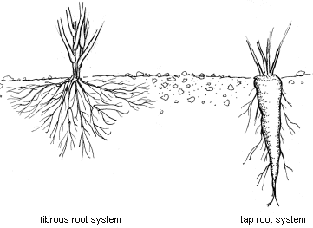
- Explain why water moves from the soil into the root hair cell.

- Suggest why root hair cells are long and thin and not short and stubby?

Please use the following QR Codes to learn more about how the cell membrane works and how these processes are used.
https://www.youtube.com/watch?v=Ao9cVhwPg84  Voyage Inside The Cell | https://www.youtube.com/watch?v=cj8dDTHGJBY  Eukaryopolis—The City of Animal Cells
https://www.youtube.com/watch?v=dPKvHrD1eS4  In Da Club—Cell Membranes and Transport | https://www.youtube.com/watch?v=5CXXuo7CgOc  cell membrane tutorial
https://www.youtube.com/watch?v=QQgXfuFyKM4  cell membrane how it works (easy way) | http://bio-chronicle.blogspot.com/2014/09/ebola.html  Ebola Virus

